2019314199 김동환

2.

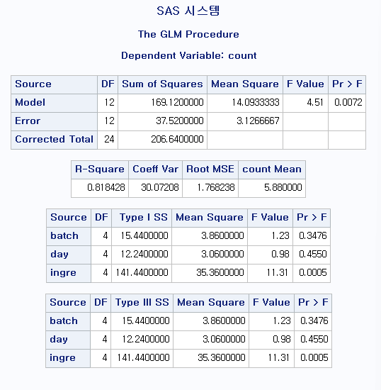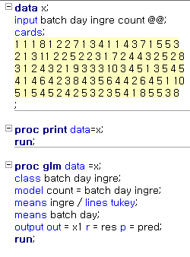

under alpha = 0.05 the block effects (batch, day) are not significant

under alpha = 0.05 the ingredient (treatment) effect is significant.

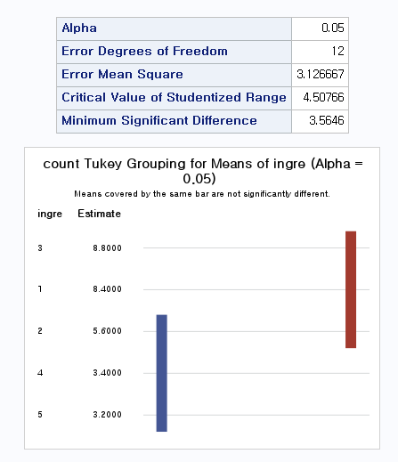

from tukey method treatment 1,2,3 have no significant differences, and treatment 2,4,5 have no significant differences.

3.

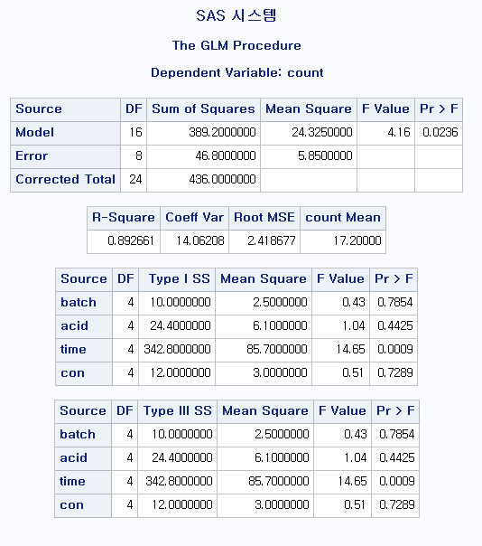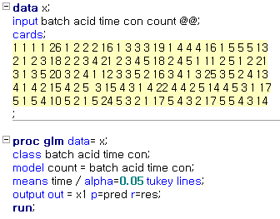

under alpha=0.05 standing times(trt) have significant effect on yield.

under alpha=0l05 block effects has no significant effect on yield.

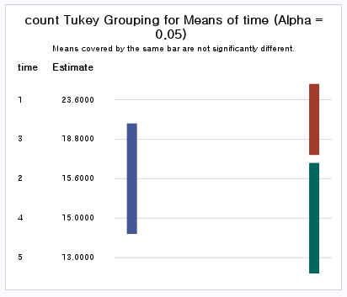

from tukey method treatment 1,3 have no significant differences, also, 3,2,4 have no significant differences and 2,4,5 have no significant differences.

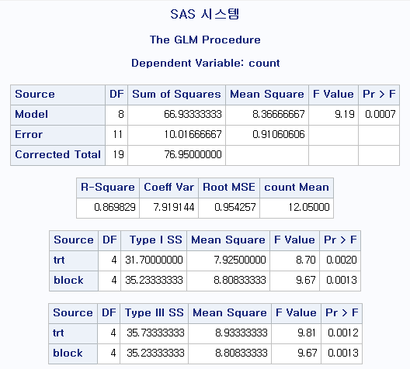4.

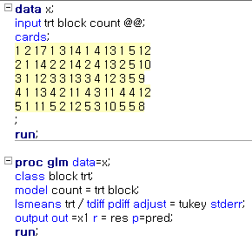

According to the result Additive have a significant effects on mileage performance under alpha=0.05

Also, Block effects significant under alpha=0.05.

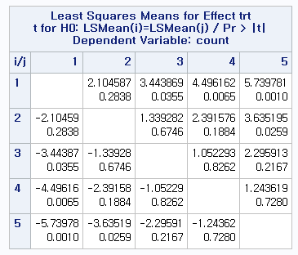from tukey method, under alpha=0.05

if p-value is lower than 0.05 we can conclude there is significant differences between means of trt effects.

5.

a)

|  |  |  |  |  |  |
| --- | --- | --- | --- | --- | --- |
| Two-way ANOVA: y versus A, B | | | | | |
| Source | DF | SS | MS | F | P |
| A | 1 | ? | 0.0002 | ? | ? |
| B | ? | 180.378 | ? | ? | ? |
| Interaction | 3 | 8.479 | ? | ? | 0.932 |
| Error | 8 | 158.797 | ? |  |  |
| Total | 15 | 347.6542 |  |  |  |

|  |  |  |  |  |  |
| --- | --- | --- | --- | --- | --- |
| Two-way ANOVA: y versus A, B | | | | | |
| Source | DF | SS | MS | F | P |
| A | 1 | 0.0002 | 0.0002 | 0.00001 | 0.998 |
| B | 3 | 180.378 | 60.126 | 3.02907 | 0.093 |
| Interaction | 3 | 8.479 | 2.8263 | 0.14239 | 0.932 |
| Error | 8 | 158.797 | 19.849 |  |  |
| Total | 15 | 347.6542 |  |  |  |

b) 4 levels

c) 2 replicates

d) Factor A, interaction are not significant, under alpha=0.05. also, B is not significant alpha=0.05

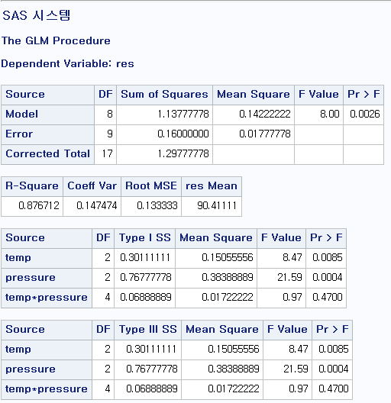6)

a) temp and pressure are significant but interaction are not

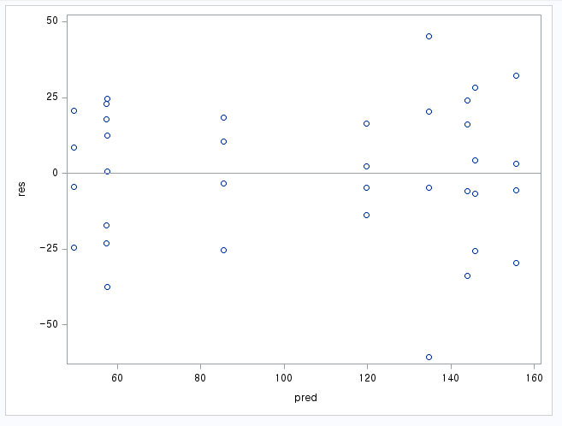b)

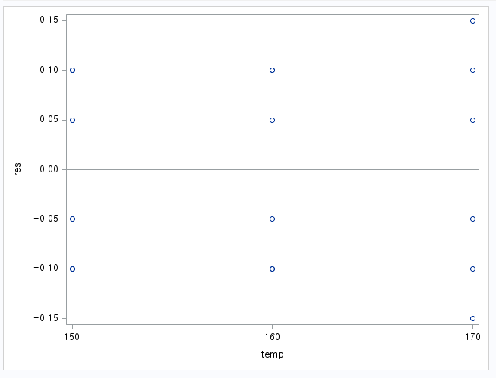

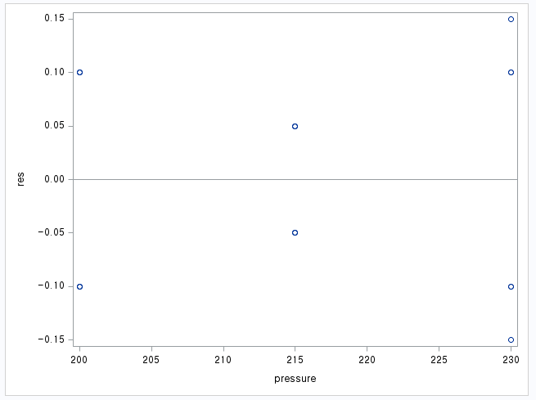

from residual plots there are no serious problem for constant variance assumptions.

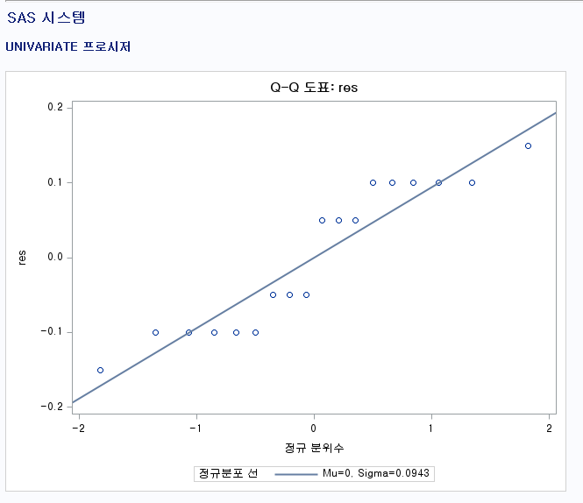

from qq plot, there are no serious problem for normality assumptions.

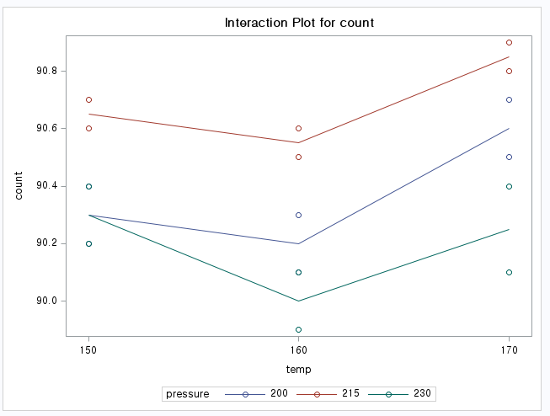c) from interaction plot set pressure 215 and temp at the high level 170 because this give the highest result.